Template  
**research article**

**Article title (English) (size 18)**

Author's name (English) (size 15)*

Name of contributor in Thai (English) (size 15)**

Name of coordinating author in Thai - if any (Corresponding author in English) (size 15)***

**Abstract** (no more than 350 words)

(size 15)..........................................................................................................................................

.............................................................................................................................................................................

.............................................................................................................................................................................

Key words: word 1, word 2, ....(no more than 5 words)....

Article printing format

- A4 paper size

- Font TH Sarabun PSK

- Length not exceeding 15 pages (including illustrations)

**Introduction**

(size 15)...........................................................................................................................................

.............................................................................................................................................................................

.............................................................................................................................................................................

**Research objectives**

(size 15)............................................................................................................................................

.............................................................................................................................................................................

.............................................................................................................................................................................

**Study of related documents and research concepts**

(size 15)...........................................................................................................................................

.............................................................................................................................................................................

............................................................................................................................................................................

**Study method (or) research method**

(size 15)............................................................................................................................................

.............................................................................................................................................................................

.............................................................................................................................................................................

**Study results (or) research results**

(size 15)...........................................................................................................................................

.............................................................................................................................................................................

.............................................................................................................................................................................

**Summarize the results (or) discuss the results.**

(size 15)...........................................................................................................................................

.............................................................................................................................................................................

.............................................................................................................................................................................

**Acknowledgments (if any)**

(size 15)...........................................................................................................................................

.............................................................................................................................................................................

.............................................................................................................................................................................

**Human research ethics (if any)**

(size 15)...........................................................................................................................................

.............................................................................................................................................................................

.............................................................................................................................................................................

References (size 15)

(The citation format used as standard in journals is APA (American Psychological Association) format.) * In the case that the article is in Thai Reference documents must be made in English only. It includes references in the text and references at the end of the article. As the following details

1. References in the content:

Refer to the author's last name. or the title in cases where the author's name does not appear, written in English only, followed by the year of publication, both documents written in Thai and foreign languages It has the following format:

(Author's surname, year of publication: page number on which it appears)

Example:

- Socrates emphasized that reading can only be sparked by what the reader already knows and that knowledge is not acquired through text (Manguel, 2003: 127).

- Sumalee Weerawong (Weerawong, 2009: 37) said that for women to go to the media to invite men to their own homes even though which he has not yet come to ask for It is against customs and traditions.

* Documents with more than 3 authors in the first citation Include the last name of every author. and when there is a reference next time Specify only the first author's last name followed by et al., e.g.

- .....while Alraimi, Zo, & Ciganek (2015) explained that MOOCs emphasize openness..............as did Alraimi et al. ( 2015) explained that the reputation of a higher education institution is a reflection of its quality…….

2. References at the end of the article:

Writing a reference list at the end of an article specifies bibliographic information for documents referenced in the text. (except for personal communications such as email communications) Private message or interview This is because it cannot be traced back and protects research data providers according to human research ethics requirements). The format of the reference list is classified according to the type of information resource. The details are as follows:

- Author identification Use last name Followed by the first letter of the initial for foreign language books. For Thai documents written by Thai people, specify their last name. and followed by full name

- Documents with content in Thai Always add parentheses to the end of the English title in Thai.

- Always use the ampersand in place of and in references. Both in citing Thai language documents and foreign language documents.

- All entries longer than 1 line should be indented by 8 characters on the next line, starting at position 9.

3. Books

Author's last name,\Author's name.\(Publishing year).\Book name\(Publishing time).\Publishing city:\Publisher.

For example: 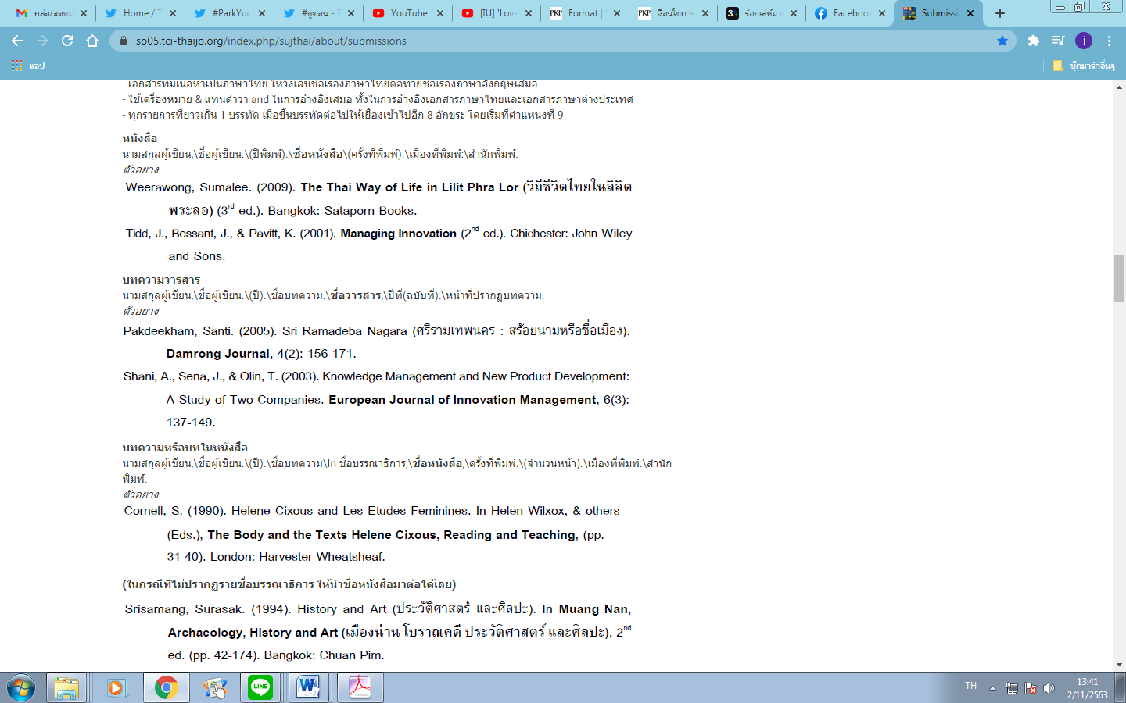

**4. Article or book chapter**

Author's last name,\Author's name.\(Publishing year).\Book name\(Publishing time).\Publishing city:\Publisher.

For example:



**5. Thesis**

Author's last name,\Author's name.\(Academic year).\Thesis name.\Degree level,\University,\City,\Country.

For example: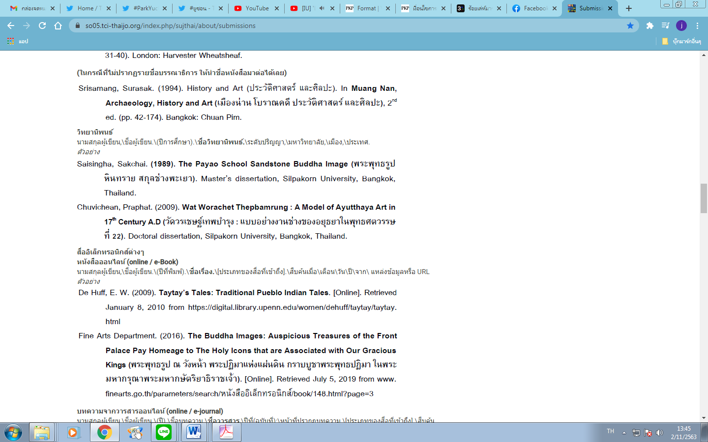

**6. Various electronic media**

Online books (online / e-Book)

Author's last name,\Author's name.\(Year of publication).\Title.\[Type of media accessed].\Retrieved\month\day\year\from\ Resource or URL

For example:



**7. Articles from online journals (online / e-journal)**

Author's last name,\Author's name.\(Year).\Article name.\Journal name,\Year(Issue):\Page where the article appears.\[Type of media accessed].\Retrieved in\Month\ Date\Year\From\Data source or URL

For example: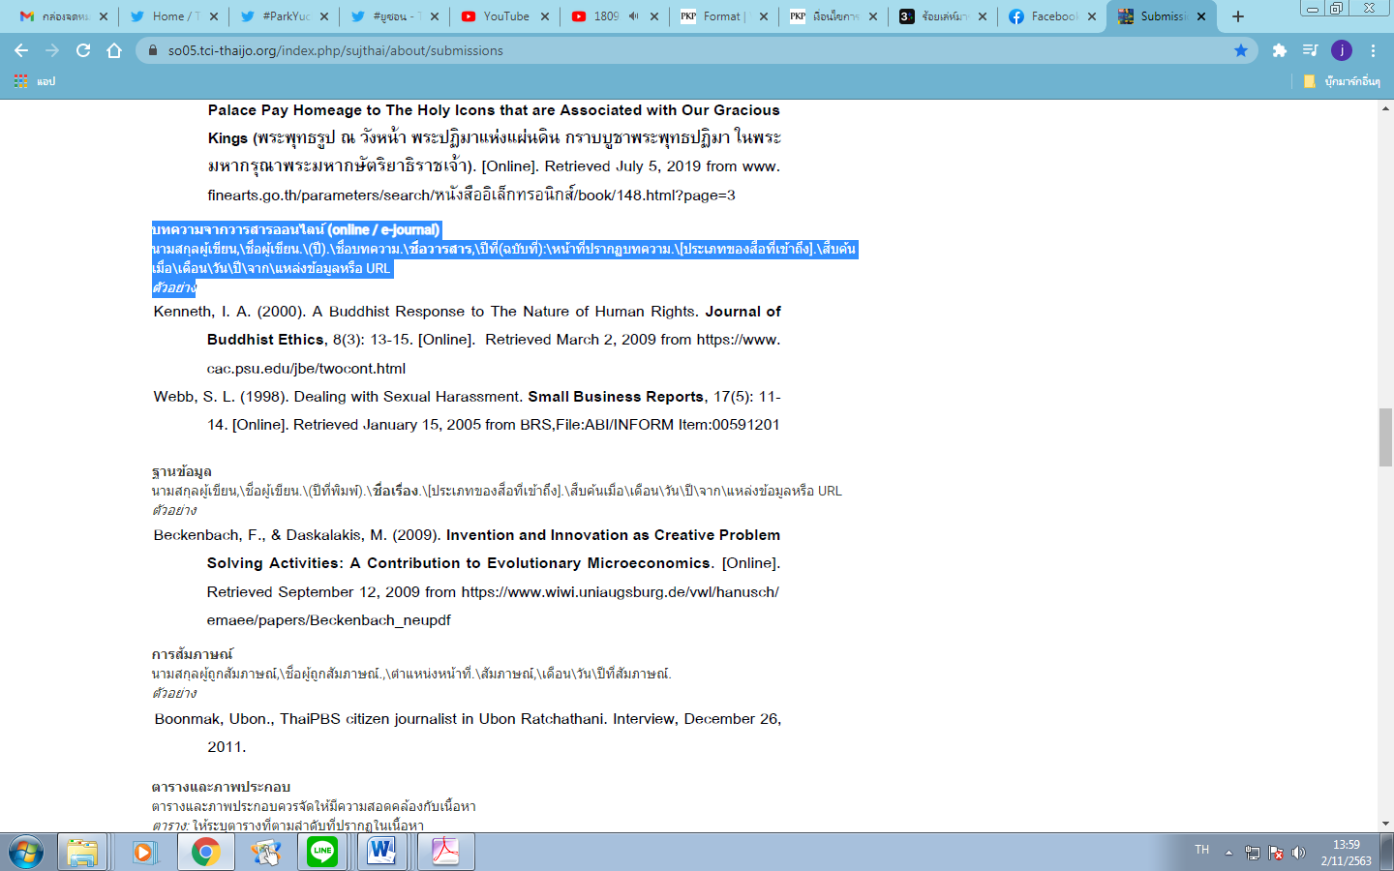

**8. Database**

Author's last name,\Author's name.\(Year of publication).\Title.\[Type of media accessed].\Retrieved\month\day\year\from\source or URL.

For example:

**9. Interview**

Last name of the interviewee,\Name of the interviewee.,\Position.\Interview,\Month\Day\Year of the interview.

For example: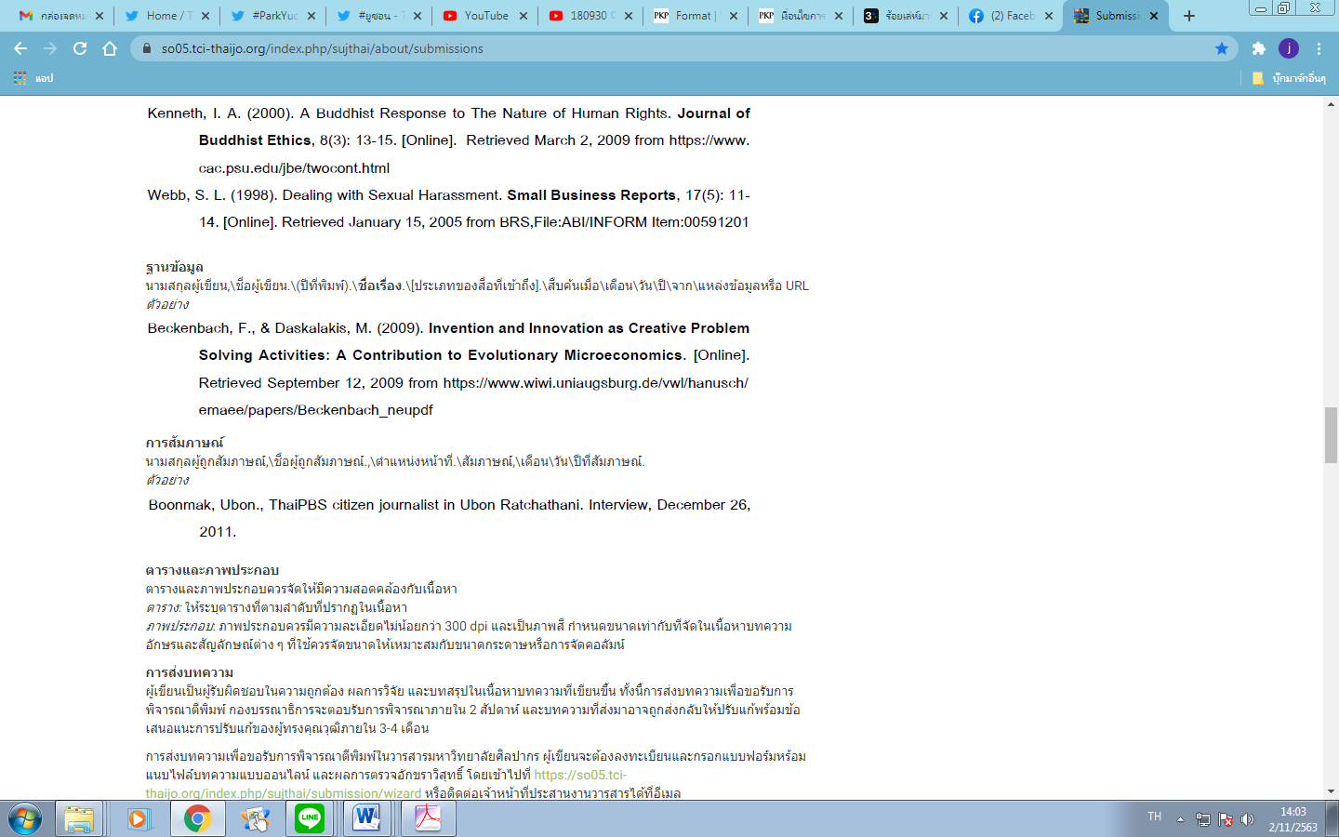

**\* Tables and illustrations**

Tables and illustrations should be provided consistent with the content.

Tables: List tables in the order they appear in the content.

Illustrations: Illustrations should have a resolution of not less than 300 dpi and be in color. The size should be the same as in the content of the article. The letters and symbols used should be sized to suit the paper size or column arrangement.